## Colocation Request

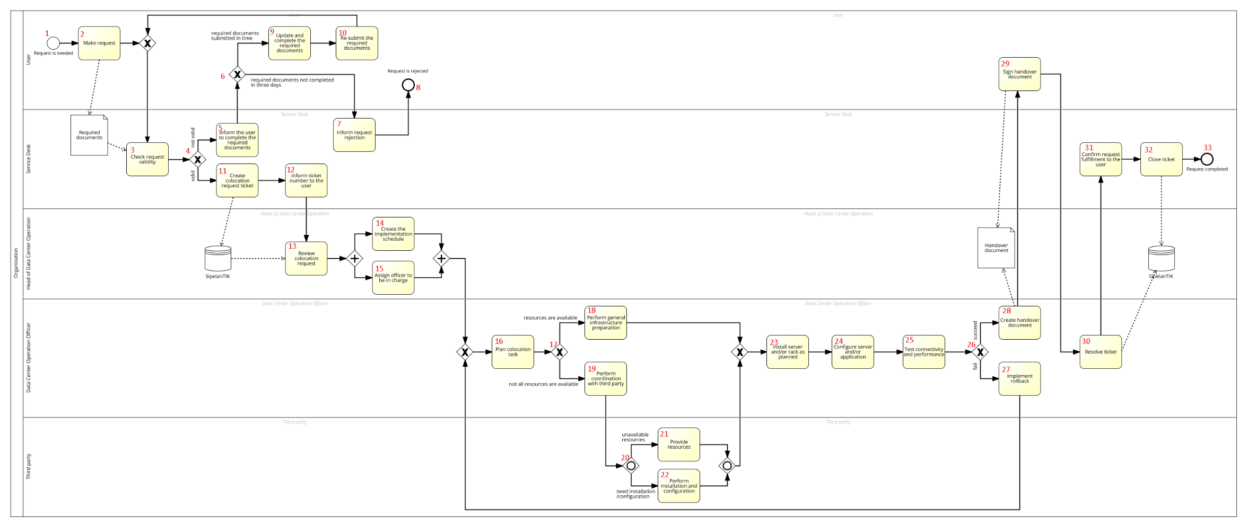

## Narration script

1. This process starts when a user needs a colocation service from Pusintek. This service is provided to allow users in the Ministry of Finance of The Republic of Indonesia to put their server and other computing hardware in the data center with the support of power, bandwidth, network, and other data center facilities provided from Pusintek.
2. The user makes a colocation server request to Pusintek by submitting the required documents.
3. Service Desk checks the request validity by checking the submitted documents. Service Desk identifies if the request is valid or not according to the validity check. This activity is performed for either new submitted documents or re-submitted documents.
4. *Option 1:* Let’s first see the case that the colocation request is not valid. *(Go to 5)*

*Option 2:* Now we will see the case when the request is valid. *(Go to 11)*

1. If the submitted documents are not valid, the Service Desk informs the user to update and complete the required documents in maximum 3 days from the day the user is informed. After getting the information from the Service Desk, user may complete and resubmit the updated required documents in 3 days or not submit it in time.
2. *Option 1:* Let’s first see the case that the required documents are not completed in 3 days. *(Go to 7)*

*Option 2:* The following steps are performed if the user submits the required documents in time. *(Go to 9)*

1. The Service Desk informs the user through an email or a phone call that his or her service request is rejected because of incomplete requirement or the user does not submit the requirements in 3 days.
2. The request is rejected. *(Go to 6, option 2)*
3. The user updates and completes the requirement as suggested by the Service Desk staff.
4. The user resubmits the requirements to the Service Desk. Then, the activities about checking the request validity are repeated for the new documents. *(Go to 4 option 2)*
5. If the required documents are complete and valid, the Service Desk records the service request into a ticketing system application (SipelanTIK).
6. The Service Desk informs the ticket number to the user. The user can refer to this ticket number when asking for the service request status to the Service Desk.
7. The Head of Data Center Operation reviews the colocation service request. He checks the information provided in the ticket to specify the schedule and resource needed for the request. The Head of Data Center Operation may then perform two activities in parallel.
8. The Head of Data Center Operation creates the schedule for the colocation task. This schedule is specified with the consideration of workload and available resources.
9. The Head of Data Center Operation assigns his subordinate to be in charge and assist the colocation implementation in the data center.
10. The Data Center Operation officer plans the colocation task by doing coordination with the user to gather information about the required resources and supporting facilities, space allocation, network allocation, testing plan, rollback plan, and time schedule. The scope of work and task and responsibility between Pusintek and the user are specified at this stage. When the required resources has been specified, it can be identified whether all resources are available in the data center or not.
11. *Option 1:* Let’s first see the case that all resources are available in the data center. *(Go to 18)*

Option 2: Following steps are performed when not all resources are available in the data center. *(Go to 19)*

1. If the required resources are available in the data center, the Data Center Operation officer prepares the network infrastructure and other supporting data center facilities according to the details specified in the planning stage. *(Go to 17, option 2)*
2. If according to the planning stage there are any resources in infrastructure or configuration that have not been available in the data center, the Data Center Operation officer will cooperate with the third party to fulfill the requirements.
3. There are two things that can be performed by the third party. The third party can perform only one or both of these activities.
4. The third party provides and prepares the infrastructure resources as needed in the request, such as preparing the network path or other resources that have not been available in the data center.
5. The third party installs and configures the infrastructure resources that have been available in the data center.
6. The Data Center Operation Officer supervises the colocation process, starting by moving and installing the server and/or its rack into the location/space in the data center as specified in the planning stage.
7. After the server and/or rack has been installed, the Data Center Operation Officer continues the process with a network configuration based on the given network allocation, and/or application configuration in the server.
8. The process continues with testing the network and performance of the server by the Data Center Operation officer to ensure that the connectivity and applications in the server run normally.
9. *Option 1:* First, let’s see the case when the network and performance test fails. *(Go to 27)*

*Option 2:* Next steps are the case when the network and performance test succeeds. *(Go to 28)*

1. If the test fails, then a rollback action is taken by the Data Center Operation Officer to revert the changes of the colocation process. Then, the process goes back to the planning of colocation task and activities following that are repeated. *(Go to 26, option 2)*
2. If the testing succeeds, then the Data Center Operation officer creates a handover document for the user. In this document, it is stated that the service provider (Pusintek) is responsible for the availability of network and other supporting data center facilities. On the other hand, the user itself is responsible for the availability of operating system, availability of applications/data, and backup of the applications/data on the server. If, in the future, the user needs to update the resource or specification of the server, then he can submit a Request For Change (RFC) through the Service Desk.
3. The user signs the handover document and gives it back to the Data Center Operation officer.
4. The Data Center Operation officer resolves the service request ticket in the ticketing system application (SipelanTIK) that indicates the service fulfillment.
5. The Service Desk confirms the user that the service has been fulfilled in accordance with the request of the user.
6. Service desk staff closes the ticket in the ticketing system application (SipelanTIK) to indicate that the request is completed.
7. The request is completed.

## Change Management Process

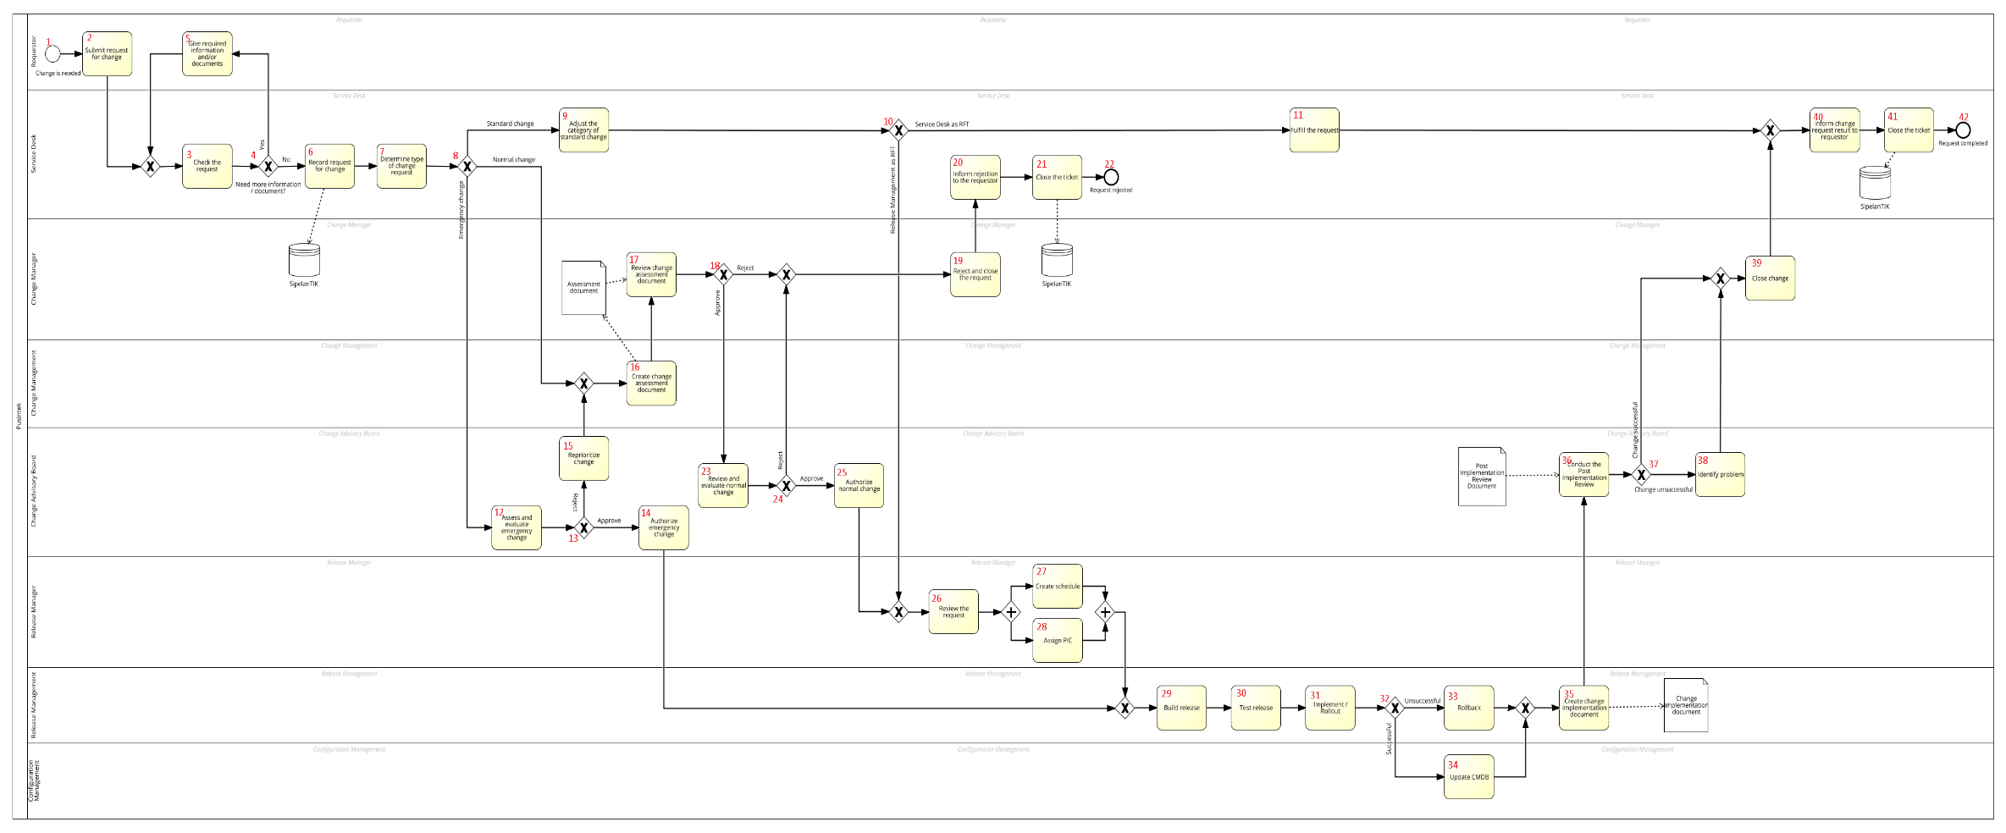

## Narration Script

1. This process starts when a user needs a change on IT services. A change is an addition, modification, or removal of a configuration item (CI), service, or service component and/or its associated elements that could have an effect on IT services.
2. The requestor submits a request for change (RFC) by providing information including description, reasons for change, impact of change, and any supporting documentation for the request.
3. Service Desk checks the request and other information and/or supporting document provided by the requestor. According to the checking step, the Service Desk decides if the request needs more information or supporting documents from the requestor.
4. *Option 1:* Let’s first see the case that the request needs more information or documents. *(Go to 5)*

*Option 2:* Next, we will see the case that no more information or documents are needed. *(Go to 6)*

1. The requestor gives the required information and/or any supporting documents. Then, the process goes back to the request checking by the Service Desk. *(Go to 3, then 4, option 2)*
2. If the information and supporting documents are complete and valid, the Service Desk records the change request into a ticketing system application (SipelanTIK).
3. The Service Desk determines the type of change request. There are three types of change: standard change, normal change, and emergency change.

In a standard change, a change is relatively common, performed according to a pre-established procedure or work instruction, and already predefined in the Service Catalogue. A standard change is pre-authorized by Change Management.

Emergency change is a change that needs to be implemented as soon as possible. Usually an emergency change request is raised by the incident management team to solve a high priority incident to immediately restore a service or to avoid an outage where no other workaround is available.

Normal change is a change that is neither a standard nor an urgent change. It is not defined in the Service Catalogue and needs to follow change management activities to get an authorization to be implemented.

1. *Option 1:* Let’s first see the condition for a standard change. *(Go to 9)*

*Option 2:* The following steps are performed for an emergency change. *(Go to 12)*

*Option 3:* The following steps are performed for a normal change. *(Go to 16)*

1. The Service Desk adjusts the category of the standard change in the ticketing system (SipelanTIK) based on the predefined criteria listed in the Service Catalogue.
2. According to its category in the Service Catalogue, each standard change has the corresponding request fulfillment team (RFT). A standard change can be fulfilled by either the Service Desk or Release Management.

*Option 1:* First, let’s see the condition if the Service Desk is responsible as the RFT. *(Go to 11)*

*Option 2:* If the Release Management is responsible as the RFT, there are several steps that should be performed before the Release management implements the change. These steps will be described later because they are common with the activities for normal change and emergency change. *(Go to 8, option 2)*

1. The Service Desk implements a change to fulfill the request based on pre-established procedure or work instruction. The activities specific for the case of a standard change and when the service desk is responsible as the RFT are completed here. *(Go to 10, option 2)*
2. An Emergency Change Advisory Board (Emergency CAB) is held to asses and evaluate the emergency request. The Emergency CAB determines the impact and plans to implement the emergency change. Testing may be reduced if necessary to deliver change immediately. The person in charge (PIC) of the implementation, rollback, and allocated resources are also determined in this step.
3. According to the result of the Emergency CAB meeting, it can be determined whether the emergency of the change request is approved or rejected.

*Option 1:* First, let’s see the case when the emergency of the change is approved. *(Go to 14)*

*Option 2:* Next, let’s see the case when the emergency of the change is rejected. *(Go to 16)*

1. The Emergency CAB authorizes the emergency change by signing the Emergency CAB approval document and allows the change to be implemented immediately. The activities specific for the case of an emergency change and when this change is approved in the Emergency CAB meeting are completed here. *(Go to 13, option 2)*
2. If the Emergency CAB considers that the change is not an emergency, the CAB reprioritizes the change so that it is then processed through the normal change flow procedure. *(Go to 8, option 3)*
3. The Change Management team creates a change assessment document consisting of the analysis of scope of work, technical and functional specification, required resources, cost, urgency, impact, risk and benefit to the current IT services.
4. The Change Manager reviews the change assessment document and uses it as a consideration to approve or reject the normal change request.
5. *Option 1:* According to the review result, the following activities are performed when the Change Manager rejects the normal change. *(Go to 19)*

*Option 2:* The following activities are performed when the Change Manager approves the normal change. *(Go to 23)*

1. The Change Manager rejects and closes the change request.
2. The Service Desk informs the requestor through an email or a phone call that his/her request is rejected by the Change Manager and explains its reason.
3. The Service Desk closes the request ticket and indicates that the request is rejected.
4. The request is rejected. *(Go to 18, option 2)*
5. Considering all supporting information and documentation, the Change Advisory Board (CAB) meeting is held to review and evaluate the normal change request for final approval. The CAB also identifies the implementation timetable for the approved changes.
6. According to the result of the CAB meeting, a normal change can be approved or rejected.

*Option 1:* In the case that the CAB rejects the normal change, the following activities are performed in the same way as the case when the Change Manager rejects the normal change request. *(Go to option 2)*

*Option 2:* The following activities are performed when the CAB approves the normal change. *(Go to 25)*

1. The CAB authorizes the normal change. This approval of change can be one of these two options: approve the change as requested or approve the change subject to specified conditions.
2. From now on, the process continues with the same activities that are performed when the Release Management is responsible as the RFT of a standard change.

The Release Manager reviews the change request. He checks the information provided in the ticket to specify the schedule and resource needed for the request. The Release Manager may then perform two activities in parallel.

1. The Release Manager creates the schedule for change implementation according to the timetable that has already determined in the CAB meeting (for a normal change) or with consideration of workload and available resources (for a standard change).
2. The Release Manager assigns a person in charge (PIC) from Release Management team for the change implementation.
3. From now on, the process continues with the same activities that are performed after an emergency change is authorized.

The Release Management carries out the release build activities by defining the delivery and deployment strategy, required resources, testing requirement, and rollback plan. A rollback plan is needed to determine the steps to be taken if a change fails during implementation or cannot be completed within the approved implementation period.

1. The Release Management then conducts a release test activity including performance, security, and functionality test.
2. The Release Management performs implementation or rollout of a change according to the schedule and deployment strategy that has been defined previously.
3. After the implementation, it can be determined whether the change is implemented successfully or not. A change is considered as successful if it is implemented in accordance with the implementation plan and timeframe, does not cause unplanned customer impact, meet anticipated objectives defined in the change request, and does not result in an outage due to the execution of the rollback plan.
4. If the change is successfully implemented, the Configuration Management then updates the Configuration Management Database (CMDB) according to the modification, addition, or removal of any configuration item in the implemented change.
5. If the change is not completed successfully as planned or incomplete, a rollback should be performed as planned.
6. The Release Management creates a documentation based on the rollout or rollback implementation result. If the rollback plan was implemented, the success of the rollback deployed needs to be documented. If, for any reason, the rollback plan was deployed and it was not successful, this also needs to be documented with details as to why it failed.
7. A Post Implementation Review (PIR) is conducted in a CAB meeting to compare the final results of a change against the original objective of the requestor.

The purpose of such review is to ensure that the change has the desired result, the implementation plan worked correctly, and the rollback plan functioned correctly, if the rollback plan was implemented.

1. After all implemented changes are reviewed, the following steps are performed based on the result of change implementation.

*Option 1:* Let’s first see the case that the change is unsuccessful. *(Go to 38)*

*Option 2:* If the change is successfully implemented, the following activities are performed in the same way as after the CAB identifies the problem of unsuccessful change implementation. *(Go to 39)*

1. If the change is unsuccessful, the CAB identifies problems encountered during implementation and opportunities for improvement. *(Go to 37, option 2)*
2. The Change Manager closes the change request.
3. The Service Desk informs the requestor about the status of his/her request, whether it is completed or failed. In this case, the same activities are performed if a standard change has been fulfilled by the Service Desk.
4. The Service Desk closes the request ticket and indicates that the request process is complete.
5. The request is complete.